

|  |
| --- |
| Audit & Ethical Hacking |
|  |
| 30 March 2020  Bucharest University of Economic Studies  CSIE Faculty, IT&C Security Master Program  Authored by: Ionescu Radu Ștefan |

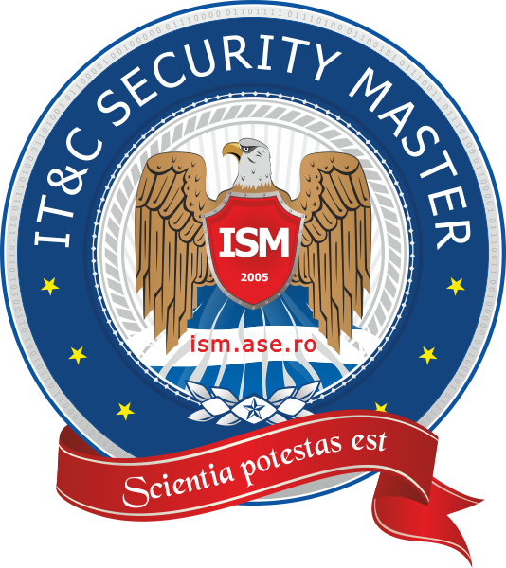

# Social Engineering - User credentials generation

## Known user information



User 1 Popescu Ion

First name: Ion

Last name: Popescu

Current location: Daia, Giurgiu, Romania

## Possible email generation

## Possible passwords generation